LAB 2: AGILE BACKLOG CREATION & SPRINT SIMULATION IN JIRA
NAME : JOSHUA JEROME
SRN : PES1UG24CS204
CLASS: 5D
Problem Statement – Vaccination Cohort & Dose Scheduling System
Name: Jose Tanmay Jerripothu
SRN: PES1UG24CS200
1. Objective
The objective of this lab is to convert the functional requirements of the Vaccination Cohort & Dose Scheduling System into Agile Epics and User Stories, prioritize and estimate the backlog, simulate two sprints in Jira, and analyse progress using the Sprint board and Burndown Chart.
2. Epics and User Stories
The five functional requirements were represented as five Epics. The Jira backlog was populated with fifteen User Stories.
Epic 1 – Vaccination Dose Interval Management (FR-001)
- Check Previous Dose – 2 points
- Calculate Required Interval – 2 points
- Block Early Booking – 3 points
Epic 2 – Citizen Registration (FR-002)
- Start Registration – 5 points
- Enter Demographic Details – 3 points
- Validate Registration Details – 3 points
Epic 3 – Vaccination Slot Booking (FR-003)
- View Available Slots – 3 points
- Select Vaccination Slot – 5 points
- Confirm Slot Booking – 5 points
Epic 4 – Vaccination Dose Recording (FR-004)
- Record Vaccine Dose – 3 points
- Record Vaccination Date – 2 points
- Update Vaccination History – 5 points
Epic 5 – Digital Vaccination Certificate (FR-005)
- Generate Certificate – 5 points
- Include QR Code – 5 points
- Verify Vaccination Certificate – 8 points
The backlog uses Fibonacci-style story-point values to represent relative effort and complexity.
3. Jira Backlog and Story Points
The Jira backlog contains the fifteen User Stories organized under their respective Epics. Each story was assigned a priority and a Fibonacci-style story-point estimate based on its relative complexity and effort.

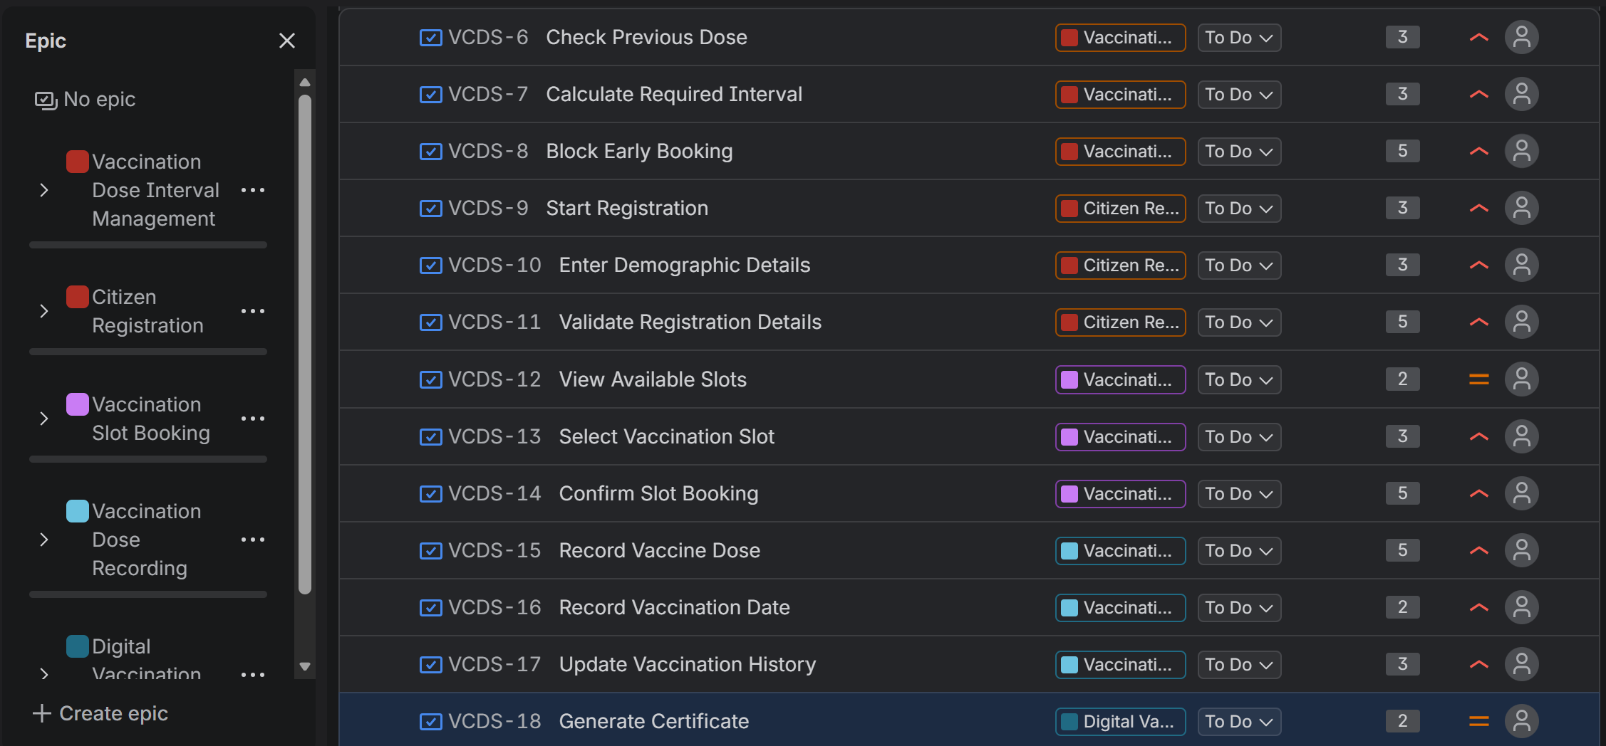
Figure 1: Jira backlog showing User Stories, Epic associations, status, priorities and story points.
4. Sprint Simulation
Two sprints were simulated in Jira. The stories were organized in a logical order according to the system workflow.
Sprint 1
Sprint 1 contained the stories related to dose interval management, citizen registration, and vaccination slot booking.
The stories were progressed through the To Do, In Progress and Done states using the Active Sprint board.

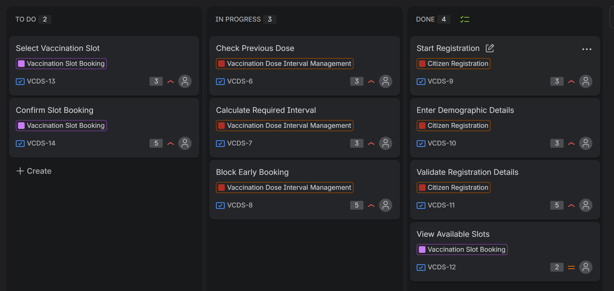
Figure 2: Sprint 1 Active Sprint board.
Sprint 2
Sprint 2 contained the remaining stories related to vaccination dose recording and digital vaccination certificates.
The stories were similarly progressed through To Do, In Progress and Done.

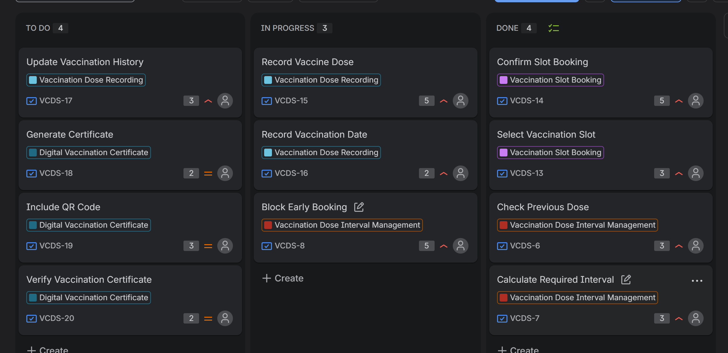
Figure 3: Sprint 2 Active Sprint board.
5. Burndown Chart
The Burndown Chart displays the remaining story points against time and compares the actual remaining work with the planned guideline.
The chart shows changes in the remaining workload as stories were progressed during the sprint. The irregular changes in the remaining-value line resulted from work being completed and sprint items being updated during the short simulated sprint.

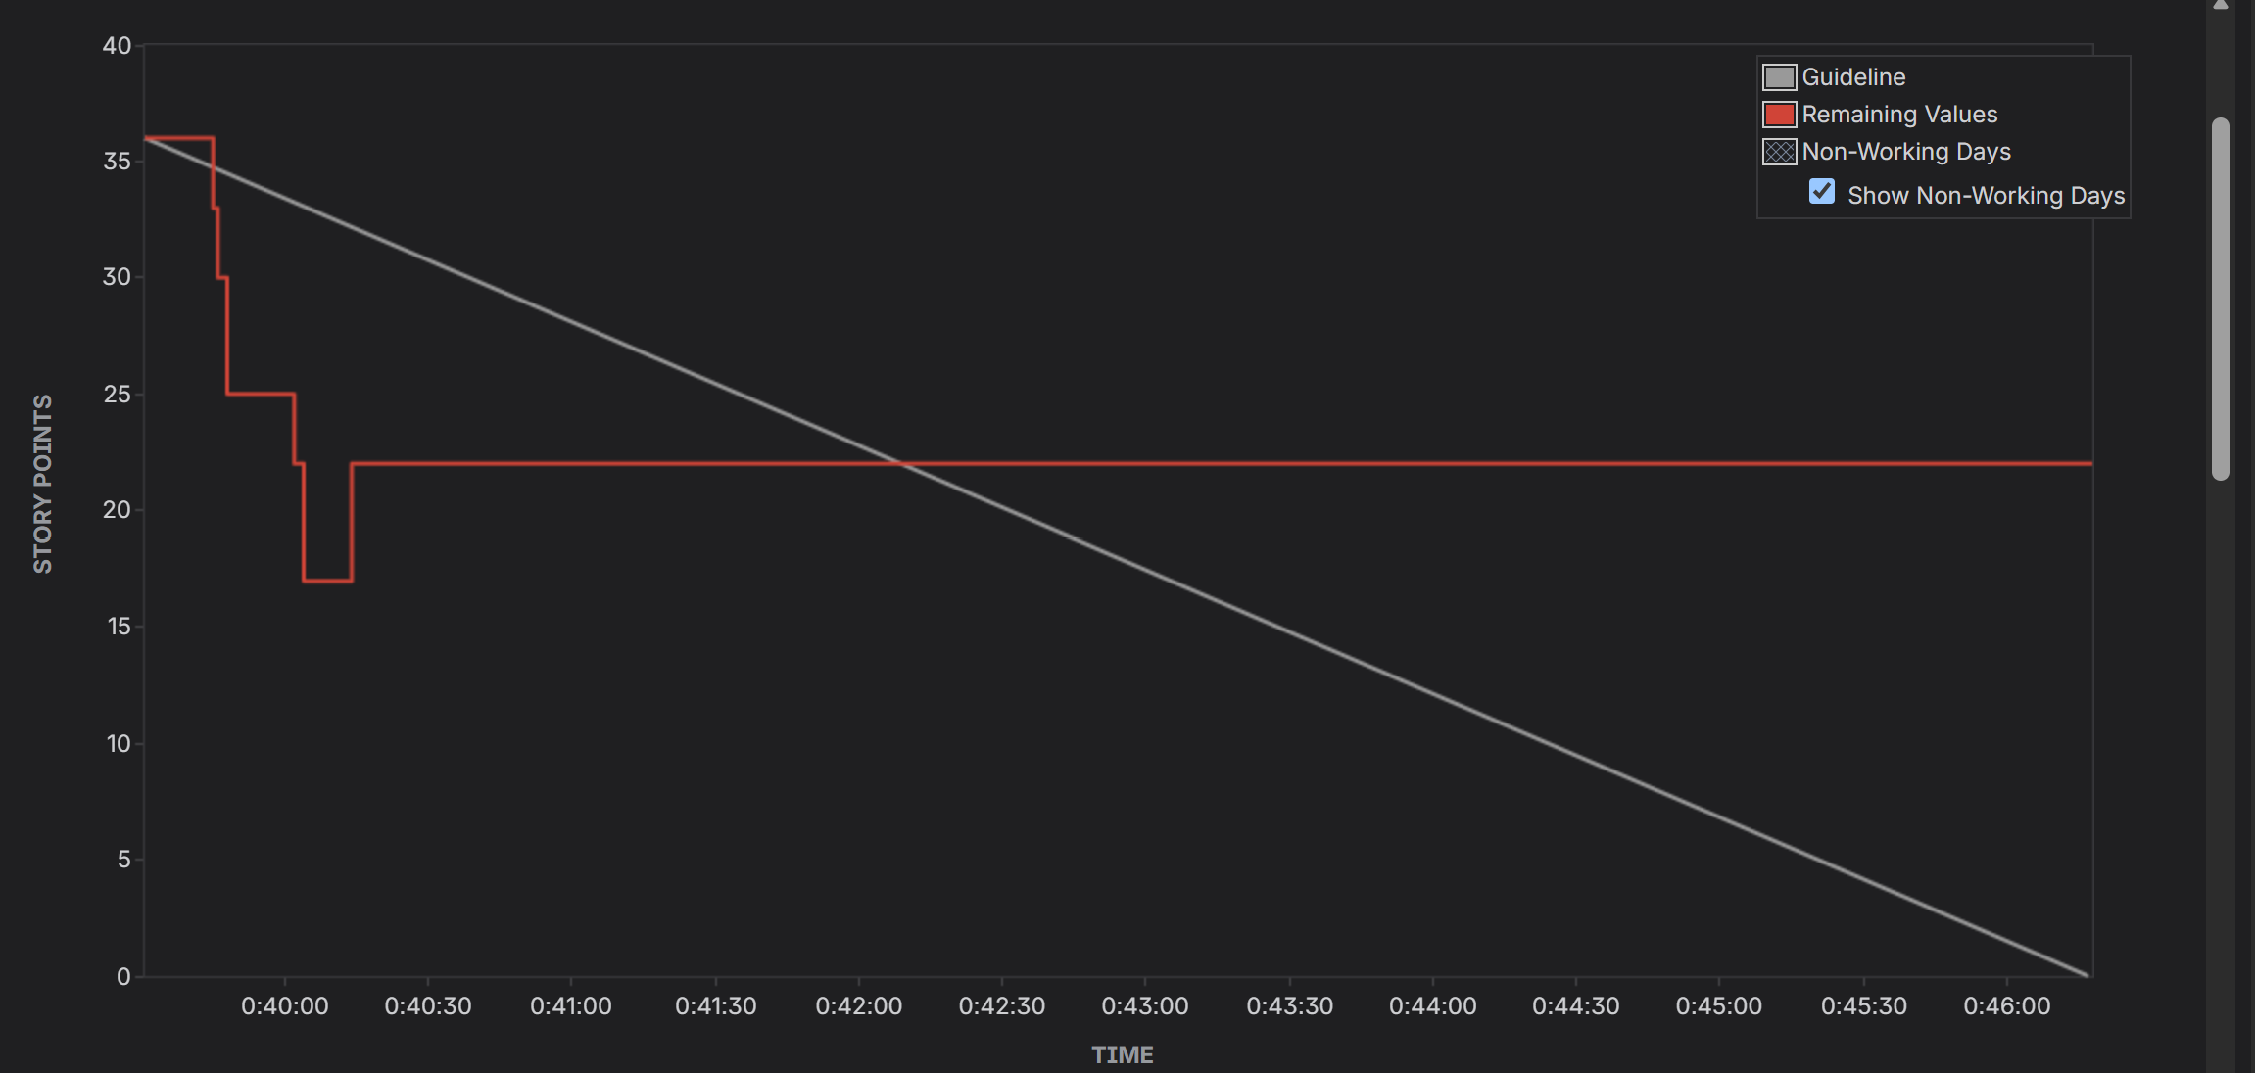
Figure 4: Jira Burndown Chart showing remaining story points.
6. Reflection
1. Did your estimations reflect the actual effort?
The story-point estimates provided a reasonable representation of the relative effort required for the User Stories. Smaller and more straightforward stories were assigned lower values, while more complex functionality such as vaccination certificate verification was assigned a higher value. Since this was a simulated lab, the estimates primarily helped compare relative complexity and sprint capacity.
2. Was your backlog well-prioritized?
Yes. The backlog was organized according to the functional requirements of the Vaccination Cohort & Dose Scheduling System. Core functions such as dose interval validation, citizen registration, slot booking and dose recording were given higher priority because they form the main vaccination workflow.
3. How did your simulated sprint align with your plan?
The simulation followed the planned Scrum workflow. The User Stories were first organized in the backlog and then assigned to two sprints. During each sprint, the stories were moved between To Do, In Progress and Done to simulate development progress.
4. What insights did the burndown chart give about your team's capacity?
The Burndown Chart provided a visual representation of the remaining story points over time. The planned guideline showed the expected reduction in workload, while the remaining-value line showed the actual progress of the sprint. The changes in the chart demonstrate how completed work affects the remaining workload and can help identify whether the planned sprint workload is realistic.
7. Conclusion
The Jira exercise converted the functional requirements of the Vaccination Cohort & Dose Scheduling System into an Agile backlog consisting of five Epics and fifteen User Stories. The stories were prioritized and estimated using Fibonacci-style story points, organized into two sprints, and progressed using the Scrum board. Finally, the Burndown Chart was generated to analyse sprint progress and remaining workload. The resulting Jira artifacts demonstrate the basic Agile backlog-management and sprint-simulation workflow.

